NAME:MOSES M MIKUYUNI

REG NO:29519/T.2022

I designed that website to show my curriculum vitae which includes education qualifications, work history my interest and hobbies as shown below.html used to design the interface of my website and use to add some details including my interests,education quarification work experience also css as a styling block i used it to design the colour,to insert pictures to my website as shown below.that is the interface of my website to show my cv.

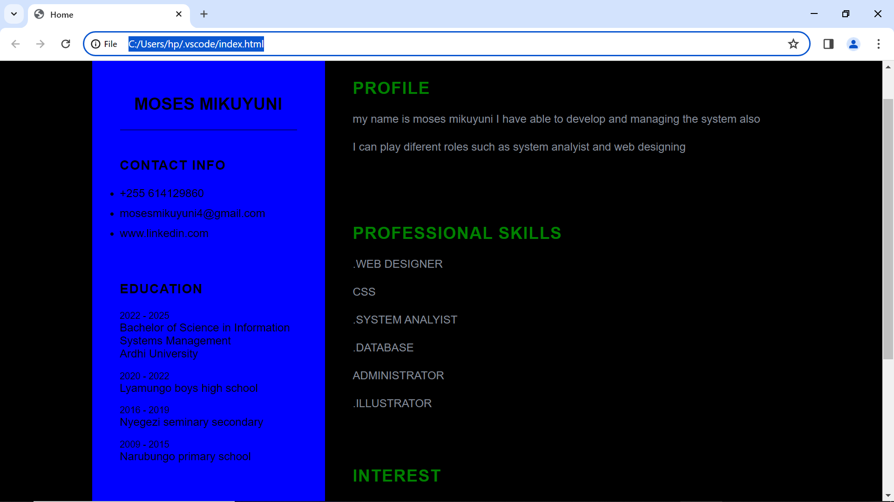

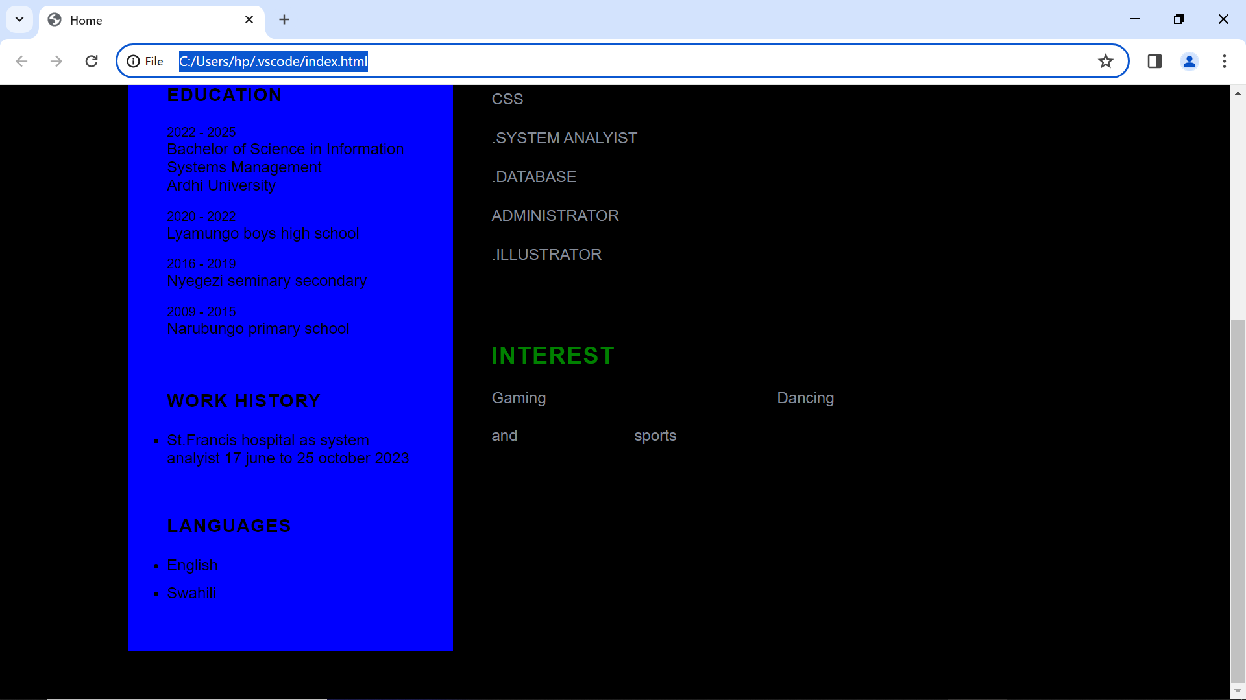

Generally my website show my curriculum vitae which includes my professions and all thing which I can done through my profession which is deals with information system management as explained in my website.also that website can help the user to sign in and can view my details about me.